AI FAQ Assistant API
MAIN PROJECT DOCUMENTATION
Technologies: Node.Js • Express.Js • Mongodb • Mongoose • Jwt • Bcrypt • Postman
Team leader: SWEDHA D
Email id: sac2427bca2892@ssacollegechennai.com
Team member: SHARMILA S
Email id: sac2427bca5284@ssacollegechennai.com
Team member: SRUTHIKA D
Email id: sac2427bca5329@ssacollegechennai.com
Team member: SUPRIYA R
Email id: sac2427bca5283@ssacollegechennai.com
1. INTRODUCTION
The AI FAQ Assistant API is a backend application developed to manage frequently asked questions and provide intelligent responses to user queries. The system combines a database-driven FAQ service with Artificial Intelligence so that common questions can be answered from stored information while new or flexible questions can be handled through an AI service.
The application is implemented as a REST API using Node.js and Express.js. MongoDB is used for storing user and FAQ information, while Mongoose provides an organized interface for database operations. JWT is used for authentication, bcrypt supports secure password hashing, and Google Gemini provides AI-assisted answer and FAQ generation capabilities.
Main Features
- User registration and login
- JWT-based authentication and protected access
- FAQ creation, viewing, searching, updating and deletion
- AI-generated answers for user questions
- AI-based FAQ generation from a topic
- API testing and demonstration using Postman
- Error handling for invalid or unauthorized requests

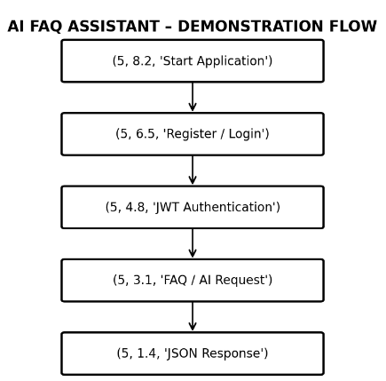
3. PROJECT OBJECTIVES
The main objective of the project is to provide a centralized and reusable API for FAQ management and AIassisted question answering. The project is designed to reduce repeated manual responses, organize FAQ information, and provide an extensible backend that can be connected to a customer-facing application.
• Centralize frequently asked questions in a database.
• Provide secure user registration and login.
• Protect restricted API operations using authentication.
• Allow authorized users to manage FAQ content.
• Support keyword-based FAQ retrieval and searching.
• Generate useful responses through Google Gemini when AI assistance is required.
• Generate FAQ question-and-answer content from a topic.
• Provide testable REST endpoints for application integration.
Expected Benefits
A structured FAQ API can improve response consistency and reduce the effort required to answer repeated questions. The AI component adds flexibility when the exact question is not already available as a stored FAQ. The modular design also makes it possible to extend the system with additional categories, clients, analytics, feedback, or other customer-support features.
3. EXISTING SYSTEM AND PROPOSED SYSTEM
Existing System
A traditional FAQ application generally depends on manually prepared question-and-answer records. Users search or browse those predefined records, and the system returns information that has already been entered. Such a system can work well for common questions, but it may provide limited flexibility when users ask questions in a different form or when new FAQ content has not yet been prepared.
• Mostly depends on predefined answers.
• New FAQ content usually requires manual preparation.
• Exact matching or keyword limitations may reduce useful results.
• Large FAQ collections can require continuous manual maintenance.
• No built-in AI response generation for new questions.
Proposed System
The proposed AI FAQ Assistant API combines conventional FAQ management with AI-based response generation. Stored FAQ records are managed through MongoDB, while questions that require intelligent assistance can be processed through . Authentication and authorization mechanisms protect restricted operations.
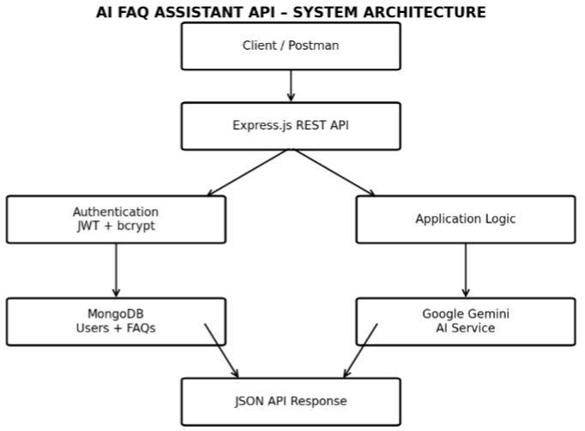
4. SYSTEM REQUIREMENTS
Hardware Requirements
- Laptop or desktop computer
- Minimum 4 GB RAM recommended
- Sufficient storage for source code, dependencies and database tools
- Stable internet connection for cloud/AI API communication 4.2 Software Requirements
- Windows, Linux or macOS
- Node.js and npm
- MongoDB / MongoDB service
- Visual Studio Code or another suitable IDE
- Postman for API testing
- Web browser and internet access
Functional Requirements
- The system shall support user registration and login
- The system shall authenticate protected requests.
- The system shall allow FAQ records to be managed.
- The system shall support FAQ retrieval and search.
- The system shall provide AI answer generation.
- The system shall support AI-based FAQ generation.
- The system shall return suitable responses for invalid requests.
Non-Functional Requirements
- Security: protected operations and hashed passwords.
- Reliability: consistent API responses and error handling.
- Maintainability: modular backend structure.
- Usability: clear request and response formats.
- Scalability: architecture that can be extended with additional services.
5. TECHNOLOGY STACK
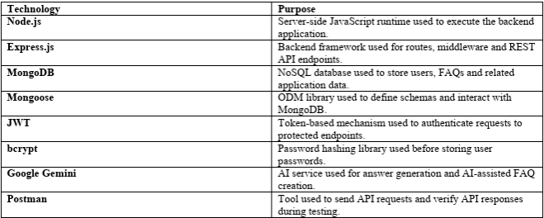
Together, these technologies form the main development stack. Node.js and Express.js handle the backend, MongoDB stores application data, JWT and bcrypt support authentication security, Google Gemini provides AI capabilities, and Postman supports testing and demonstration.
6. SYSTEM ARCHITECTURE AND DATA FLOW
The system architecture describes the interaction between the client, backend API, authentication layer, database, and AI service. A client or Postman sends an HTTP request to the Express.js server. The server validates the request, checks authentication when required, performs database operations or sends an AI request, and finally returns a JSON response.
Main Components
- Client / Postman – sends HTTP requests and receives API responses.
- Express.js Server – handles routes, middleware and application logic.
- Authentication Layer – verifies JWT tokens for protected resources.
- MongoDB – stores user and FAQ documents.
- Google Gemini – processes AI-related questions and generates responses.
- JSON Response – carries the final result or error information back to the client.
7. DATABASE DESIGN
MongoDB is used as the primary data store. The application can organize its information into collections such as Users and FAQs. Each collection contains document records represented in a JSON-like structure.
User Data
A user record may contain a unique identifier, name, email, hashed password and timestamps. Passwords should not be stored as plain text.
FAQ Data
An FAQ record may contain a question, answer, category, creator information and timestamps. These fields allow the application to organize and manage frequently asked questions.
{
"question": "What is Node.js?",
"answer": "Node.js is a JavaScript runtime for server-side development.",
"category": "Programming"
}
Database Processing Flow
API request → Express.js route → Mongoose model → MongoDB operation → result → JSON response
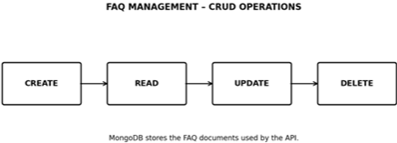

8. USER AUTHENTICATION AND SECURITY
Authentication verifies the identity of a user before allowing access to protected resources. The project uses registration and login operations followed by JWT-based authentication. Passwords are processed using bcrypt hashing rather than being stored directly.
Registration
During registration, the user submits basic details such as name, email and password. The server validates the input, hashes the password, stores the user record and returns a suitable success response.
Login
During login, the server verifies the submitted credentials. If the credentials are valid, a JWT token is generated. The client can then send the token with protected requests.
const token = jwt.sign(
{ userId: user._id },
process.env.JWT_SECRET
);
8.3 Protected Request A protected endpoint checks whether a valid JWT is present before processing the request. This mechanism helps prevent unauthorized access to resources such as user profiles or restricted FAQ operations.
9. FAQ MANAGEMENT
FAQ management is a central part of the application. Authorized users can create, retrieve, search, update and delete FAQ records. These operations correspond to the common CRUD model used in database applications.
Create FAQ
{ "question": "What is cloud computing?",
"answer": "Cloud computing provides computing services through the internet.",
"category": "Technology"
}
Search FAQ
The search function accepts a keyword or query and returns relevant FAQ records from the database. This allows users to find stored answers without manually checking every record.
Update and Delete
Authorized operations can modify an existing FAQ or remove it when necessary. Authentication and ownership rules can be applied to prevent unauthorized modifications.
10. AI ANSWER GENERATION
The AI answer generation module allows the client to submit a natural-language question to the backend. The API receives the question, prepares the required AI request, communicates , and returns the generated response
Example Request
{
"question": "What is artificial intelligence?"
}
Example Response
{
"answer": "Artificial Intelligence enables computer systems
to perform tasks that normally require human-like intelligence."
}
The AI response is returned to the client through the API as structured data. The exact response depends on the question, the configured AI service, and the application logic.

11. AI FAQ GENERATION
The AI FAQ generation module helps create FAQ content from a topic. Instead of manually preparing every question and answer, a user can submit a topic and the backend can request suitable FAQ content from the AI service.
Processing Flow
Topic → AI FAQ endpoint → Express.js processing → Google Gemini → generated question and answer → JSON response
Example Input
{
"topic": "Cloud Computing"
}
Example Output
{
"question": "What is cloud computing?”,
"answer": "Cloud computing provides computing resources
and services over the internet."
}
This feature can reduce the manual effort involved in preparing FAQ material and can be useful when FAQ content needs to be generated for multiple topics.
12. API DOCUMENTATION API
documentation defines the available endpoints and describes what each endpoint is intended to do. It helps developers understand the request method, authentication requirement, input information and expected response.
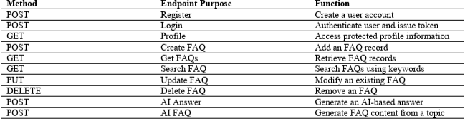
13. TESTING AND DEMONSTRATION
Testing verifies that the API endpoints perform their intended operations and return suitable responses. Postman can be used to send requests with valid and invalid input and to inspect the returned status codes and response bodies.
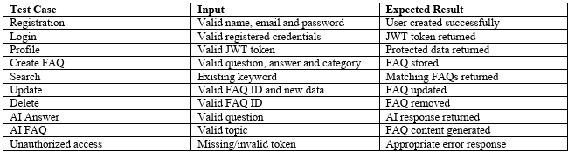
Error Handlin
Appropriate error response The API should handle invalid input, missing fields, authentication failures, unavailable records and server-side failures in a controlled manner. Meaningful error responses help the client understand what went wrong and make the system easier to test and maintain.
API Testing Specification
1. User Registration
Route: POST /api/auth/register
Access: Public
{
"name": "kalpana",
"email": "user@example.com",
"password": "yourpassword"
}
2. User Login
Route: POST /api/auth/login
Access: Public
{
"email": "user@example.com",
"password": "yourpassword"
}
3. Create FAQ
Route: POST /api/faqs
Access: Private – Bearer JWT Token
{
"question": "What is Node.js?",
"answer": "Node.js is a JavaScript runtime environment.",
"category": "Programming"
}
4. Search FAQ
Route: GET /api/faqs/search?q=node
Access: Public or according to the implemented route authorization.
5. Generate FAQ Using AI
Route: POST /api/ai/generate-faq
Access: Private – Bearer JWT Token
{
"topic": "Node.js and Express.js"
}

14. PROJECT DEMONSTRATION
The final demonstration presents the complete working flow of the AI FAQ Assistant API. It begins with user registration and login, continues with JWT-protected access and FAQ management, and then demonstrates the AI answer and AI FAQ generation features.
15. FUTURE ENHANCEMENTS
- Customer-support chat interface
- Multilingual FAQ and AI responses
- Admin dashboard and usage analytics
- User feedback and response rating
- Advanced search and filtering
- FAQ categories and reporting
- Integration with websites or customer-support platforms
- Role-based access for administrators and normal users

12.Screenshots

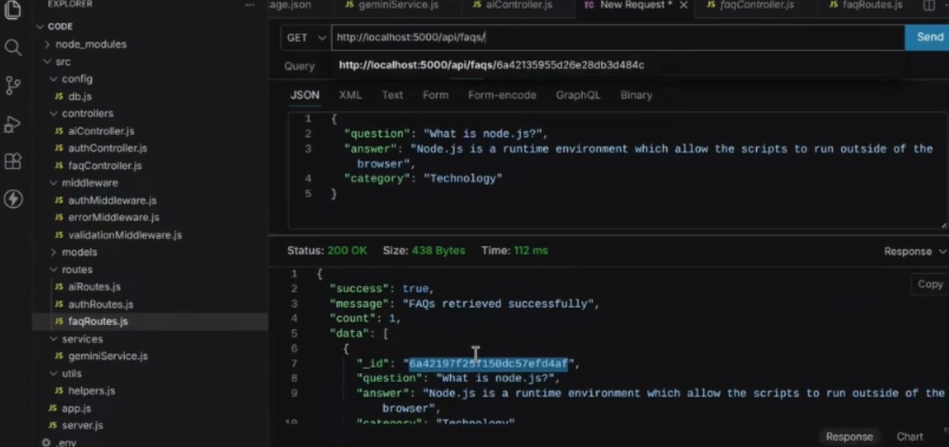

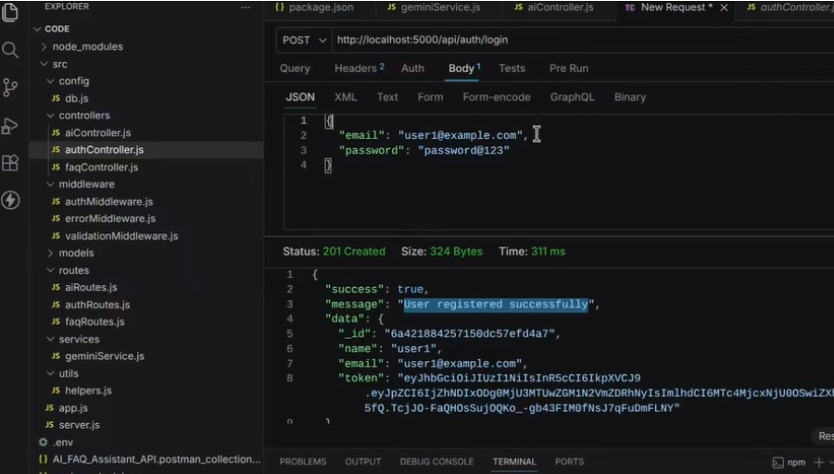

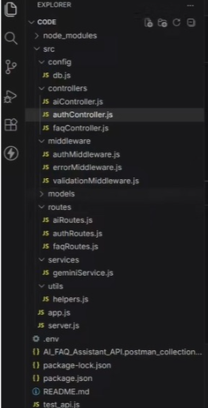
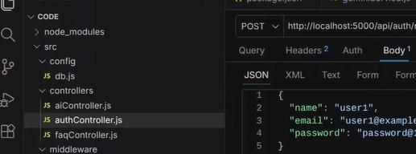

16. CONCLUSION
The AI FAQ Assistant API combines structured FAQ management with AI-powered response generation to provide a flexible backend service. The project demonstrates how Node.js, Express.js, MongoDB, JWT, bcrypt, Google Gemini and Postman can work together in a practical REST API application. The main documentation records the project objective, requirements, technology stack, architecture, database design, authentication, FAQ operations, AI functionality, API structure, testing and demonstration flow. This provides a clear reference for understanding, maintaining, testing and extending the project.

API TESTING VEDIO:
https://drive.google.com/file/d/1GGYk_QGy8MjuK8cxr21bketIwQxsi3Rh/view?usp=sharing
DEMO LINK:
https://drive.google.com/file/d/1RjKWjdMI2fLduq-QJfiJIiOCjonvBL1s/view?usp=sharing
CODE LINK:
https://drive.google.com/drive/folders/1aUqV5q25fE_iUPwWcLt02eJ-v-ytxpjz?usp=sharing

